If your child is staying for lunch with us then they will need to bring in a packed lunch from home with them (please be aware we cannot reheat food).
We are required to encourage children to learn about a healthy lifestyle and to follow healthy eating guidelines within the setting and ask that lunch boxes from home do not contain sweets, chocolate etc. Below are some examples of our childrens lunches.
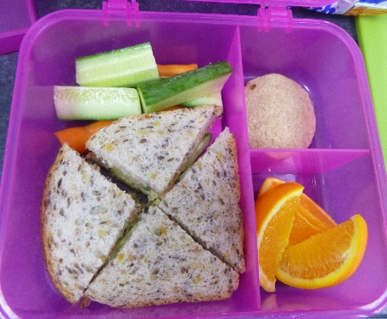
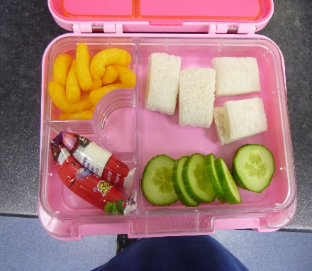

Please note:
- No drinks are necessary, milk and water is provided.
- Lunch boxes should be kept small due to fridge space and MUST be labelled.
- We need to have a nut free policy due to allergies so no nuts and foods containing nuts should be included in lunch boxes. Chocolate spreads will not be served as we cannot be sure it is nut free.
- Popcorn, fruit strings and winders present a choking hazard to young children and we would ask you not to include these in your childs lunch.
- Any food packets that state `not suitable for 36 months` will not be given to our 2 year olds.
- Please ensure that grapes and cherry tomatoes are cut into quarters lengthways to avoid choking hazard.
- Use by dates should be checked as we are unable to serve out of date items.

Please read the enclosed ‘Early Years food choking hazards’ information sheet for safe preparation of your child’s lunch.

Please speak to your key carer if you have any concerns about your child`s diet, we usually put uneaten foods back in their lunch boxes so you know what has been consumed.

